Shabbos Stories for
Parshas v’zos habracha 5781
Volume 12, Issue 5 23 Tishrei/October. 11, 2020
Printed L’illuy nishmas Nechama bas R’ Noach, a”h

For a free subscription, please forward your request to keren18@juno.com
Past stories can be found on the website ShabbosStories.com

The Guest Who
Wore All White
By Tuvia Litzman

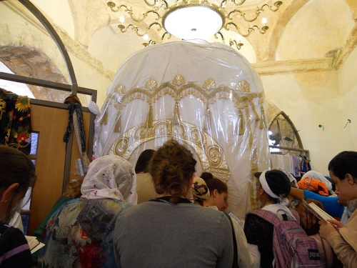

A Jewish woman in Jerusalem who was not blessed with children after many years of marriage, felt more and more distressed with each passing year. She visited many righteous people and prominent rabbis and asked them to bless her, but she remained childless.
One day, a woman acquaintance gave her a strong recommendation: many women in a similar situation had received the gift of children after praying at the tomb of our matriarch “Mama Rachel” in Beit Lechem ("Bethlehem').
The childless woman decided to take upon herself to say the whole book of Tehillim (Psalms) once a week at the gravesite of “Mama Rachel”. She fulfilled her commitment, and to her immense delight she became pregnant and later that year gave birth to a baby boy.

A Cause for Pure Joy and Excitement
This became cause for pure joy and excitement for all her family and friends and neighbors, since she had been married for twenty years until this first child. The new mother knew in her heart that he was born in the merit of our Matriarch Rachel, and she felt strongly that she wanted to give "Mama Rachel" a personal invitation to the brit mila (circumcision ceremony).
She wrote a nice invitation, put it into a white envelope and made a special trip to Beit Lechem in order to place the invitation on "Mama Rachel's” tomb. When she approached the tomb, she saw that a large number of Israeli soldiers were positioned around the building.
The soldiers explained to the woman that riots were going on and the Arabs were throwing rocks at anyone who attempted to approach. They refused to allow her to go inside, not even for the brief two minutes she was begging them for. They kept repeating that it was too dangerous.

She Refuse to Give Up
She, however, refused to give up. She approached a small group of the Palestinian policemen and in Arabic explained the reason for her visit. She pleaded with them to let her go inside. They appreciated her plea, the highest ranking one gave an order, and four armed Arab policemen escorted her into the building over the grave.
She put the envelope on the tomb, expressed a few words of warm gratitude, said a few chapters of Tehillim and left the place, again escorted by the policemen, whom she thanked.
A large number of people came to the circumcision - relatives and friends, and others as well who had heard about the 'miracle' birth after twenty years. Everyone wanted to participate in the exalted joy of the special occasion. One close friend even arranged for a video photographer to film the event.
A few minutes before bringing the boy into the Covenant of Abraham, a beautiful, refined-looking woman entered the hall. She wore a long white dress and made such a strong impression that many women stood up and pressed her hand, despite the fact that they had no idea who she was.
The woman approached the mother of the boy, embraced her, kissed her on her cheeks and wished her 'Mazal Tov'. The brit was performed and everybody felt the exceptionally great joy.
After a few days the family received the video film of the brit, and a CD in order to watch the movie on their computer. As they stared at the screen, they saw something very strange: one of the women got up from her seat, smiled, and pressed her hand - into thin air! After that, another woman got up and pressed her hand in the air. This happened a few times, always with a different woman.
Then, they saw how the mother of the boy made a motion as if embracing somebody and offering her cheeks for a kiss - but without seeing any person doing it! They watched the movie over and over again with the same strange events repeating themselves.
Finally they realized that the video camera simply did not catch the beautiful woman dressed in her white frock. According to Jewish custom, if you are personally invited to a brit mila, it is such an important occasion that you have to come…. Reprinted from Chassidic Gems II

The Strange Buckets of Soil
A man arrived at the border in a new Mercedes, and he wanted to cross the border. The border police checked his luggage to see whether he was bringing undeclared merchandise across the border, and all they found were buckets of soil. "What is this for?" they asked.
"I’m building a new home, and the earth I need for the building is cheaper in the other country. So I go there and fill up buckets with dirt…"

Just to Save a Few Pennies?
They didn’t believe him. It was strange that one would import soil, just to save a few pennies. So they sifted through the earth expecting to find something hidden there, but they didn’t find anything, and they let him pass.
The following day, he came to the border again, riding in his brand new Mercedes. The border patrol sifted through the soil, didn’t find anything suspicious, and let him go on his way.
This happened every day for months. After a while, they stopped sifting through the earth because they saw that there was nothing there.
One day, he came to the border and told the guards that he wouldn’t be coming anymore.
"I finished building my house, so there's no reason for me to bring more earth."
The border police couldn’t contain their curiosity any longer, and they asked him, "Why were you bringing earth every day? Was it just to save a few pennies?" He replied, "I'll tell you if you promise that you won’t arrest me and that you won't report me to the government."

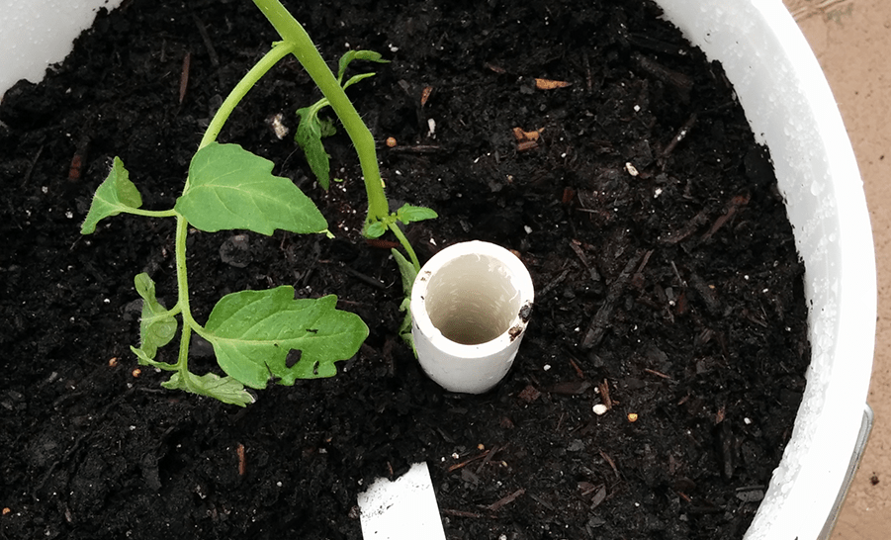

The Soil was Just a Coy
They promised. He said, "I was importing Mercedes cars. Every day, I drove a new Mercedes. The soil was just a coy…"
The soil caused the police to focus on that and to lose sight to a greater felony that was happening. If he would have driven through with just the Mercedes car (without the soil), they would probably suspect that he was importing the vehicle.
The nimshal is, there is a lot to focus on these days. We can focus on being happy, on the greatness of the mitzvos, on the lessons of the mitzvos, on Torah and tefillah, etc. But then something trivial happens, and people tend to turn all their focus to that. We have to remember that we don’t have time for that. There are greater things to think about at this time.

Reprinted from the Succos 5781 email of Torah Wellsprings: Collected Thoughts from Rabbi Elimelech Biderman.
The Best Hospital
In Los Angeles

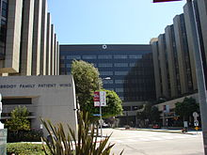
Cedar Sinai Hospital, Los Angeles

A person must realize that it’s not his brains, talents, or cleverness that help him acquire wealth. Rather it is his Siyata D’shmaya—help from Heaven. It is also his mazal—fortune that G-d decides to be kind to him.
Rabbi Ashear told a story about a rabbi in Los Angeles who experienced the great Hand of Hashem. He had a slight cough that turned into pneumonia, and his doctor recommended he go to the hospital to get IV antibiotics.
He went to Cedar Sinai Hospital, the best hospital in LA. He got evaluated, and they informed him the doctors in the hospital didn’t take his insurance. He was prepared to pay, but the doctor told him, “Don’t waste your money. This is a pretty standard case. Go to your local hospital and let them give you IV and you’ll be fine.”
He went to a local hospital that took his insurance, and everything was fine. He made a swift recovery. He was set to be discharged on a Friday afternoon. The rabbi’s wife left to prepare for Shabbat while the hospital prepared the rabbi for discharge, and one of the rabbi’s students came to keep him company in the meantime.
While the student was there, the nurse came in and said, “Okay, you’re free to go!”
The rabbi got up and got his things together, and suddenly lost his color.
The student asked his rabbi if he felt okay, and the rabbi said, “No, please call the nurse.”
The nurse came in and looked at him and called, out “Code Blue, cardiac arrest! Cardiology to Room 204!!”
No one responded. The nurse was frantically paging the cardiology department in the hospital, but no one was answering. Someone walked out of the room next door to the rabbi’s and said, “I’m a cardiologist I can help you.” The top Cedar Sinai cardiologist happened to be visiting his friend in the next room.
The doctor went to work on the rabbi. His heart had stopped, but the doctor helped to bring him back. Hashem put the rabbi exactly where he needed to be just at the right time!!
Whether the gifts from Hashem are seemingly small and unnoticeable, or life-saving and obvious like this rabbi’s story, we must “bring Bikkurim,” and have immense gratitude and hakarat hatov for all the amazing things Hashem does for us.

Reprinted from the Parshat Ki Tavo 5780 email of Rabbi Amram Sananes as written by Jack E. Rahmey.

A Basketball Coach's
Change of Career
By Dovid Zaklikowski

Abe Sacks, a high school basketball coach and former trainer with the Harlem Globetrotters basketball team, was glued to his television screen. It was 1973 and running on television there was a series called "Religious America," which focused on the spiritual lives of different Americans. That week the television displayed scenes of Lubavitch life in Crown Heights, Brooklyn: prayers with the Lubavitcher Rebbe… a Chassidic wedding… the circumcision of an eight-day-old boy. Abe was transfixed. Most of all he was captivated by the images of the Rebbe himself.
On an impulse, as soon as the show was over Abe caught a train and headed to the address he'd seen on the screen, "770 Eastern Parkway," the central synagogue of Lubavitch.
He was immediately greeted by Chassidim on the street with the now-familiar question: "Would you like to don tefillin?" Already inspired, on a high, he agreed to don tefillin, something he had not done for over thirty years. In response to his question when and where he could meet the Rebbe face to face, he was told the date of the next farbrengen (public Chassidic gathering).
From that day on, Abe made sure to put on tefillin daily.

The day of the farbrengen arrived, and Abe made sure to arrive a few hours early to secure a good seat. He found the singing and clapping absorbing, but once again the most precious part of the experience was simply the opportunity to catch a glimpse of the Rebbe's face. The sight gave Abe an indescribable, jubilant feeling.

Abe became a frequent visitor to the red brick building on Eastern Parkway. Whenever he felt down he would travel to 770. He didn't mind the long trip; seeing that smile and those eyes made it all worth it. And of course, at every farbrengen with the Rebbe, Abe was there, clapping and singing along with the crowd.
One day, the Rebbe informed his secretaries of his intention to conduct a sudden surprise farbrengen. Word spread quickly amongst the Chassidim who quickly ran to 770.
Abe arrived at 770 next morning, found out about the farbrengen the night beforehand, and was deeply disappointed to have missed it. He consoled himself with the thought that he would soon see the Rebbe as he entered the prayer hall for morning prayers.
When the Rebbe entered the room, instead of heading directly to his place, he stopped and spoke to Abe, "I did not see you yesterday, where were you?" Abe replied that he had not been told about the surprise gathering.
"Nobody informed you?!" the Rebbe asked.
From then on, somebody made sure to inform Abe every time a farbrengen was to take place.

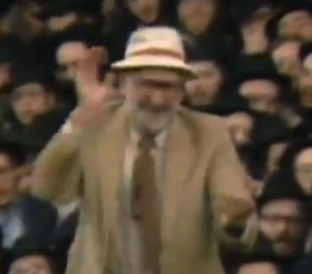
Abe Sacks, a”h, celebrating at a farbrengen at 770

Abe slowly learned and acquired knowledge about his Jewish heritage. Various individuals "coached" him, and he constantly received encouragement from the Rebbe.
At first, Abe did not know how to read Hebrew. One night while reciting the Shema in English. He burst into tears, distraught. "Why can't I read the Hebrew? Why am I not able to recite the Shema and the other prayers in the original Hebrew – the holy language?" he whispered in anguish.

“The G-d Almighty Understands
All Languages, English as Well”
The next day Abe traveled to 770 to cheer himself up. He stationed himself in the foyer at the entrance of 770, outside the room where the Rebbe was listening to the reading of the Torah. On his way back to his office the Rebbe met Abe. Before Abe had a chance to utter a word, the Rebbe said with a wide smile: "G-d Almighty understands all languages, English as well."
Another time, unable to sleep, Abe arrived in 770 in the early hours of the morning. The Rebbe was then on his way out, heading home after many hours of receiving people in private audiences. Seeing Abe, the Rebbe told him, "A Jew has to sleep in order to have strength for the next day."
Abe replied, "You also do not sleep much at night."
Said the Rebbe, "I do not sleep because I am worried and preoccupied with the many requests I receive. However, why don't you sleep?"
When retelling the story years later, Abe said, "From then on I tried to sleep at night, so the Rebbe wouldn't worry about me!"
Over the years, Abe learned Hebrew and began attending classes at Hadar HaTorah, an academy for beginners in Jewish practice, located in Crown Heights.
Abe particularly enjoyed a program known as "Encounter with Chabad," wherein people from all walks of life would come to spend a weekend with the Crown Heights community and learn more about their heritage. He would participate in the entire program of speakers and lectures.
Once, when a group of college students came to Crown Heights for an "Encounter" weekend, the Rebbe saw Abe with them and instructed him, "'Coach' the students in Judaism."
Having been coached himself, he was now able to coach others. And a basketball coach also became a Judaism coach.
Following Abe's passing on Shabbat, November 3, 1985 (the 3rd day of Kislev, 5746), the Rebbe paid for the arrangement of his burial and the reciting of the mourners' Kaddish.¹

Reprinted from the website of Chabad.Org

